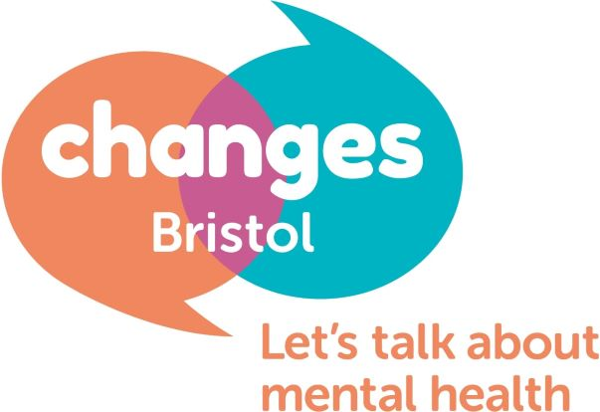

Dear Applicant,
Reference: Befriender Service Manager Vacancy
Please find enclosed an Application Form, Guidance notes, Job Description & Person Specification for your attention. The Equalities Form should be completed online.

This is a fantastic opportunity to be a part of a unique charity that is peer led and focussed on the wellbeing of its members and service users. We are looking to employ a person on a full-time 37.5 hours fixed term 1 year contract to manage the Befriender Service. This is a new service set up to respond to the COVID19 pandemic and is now being expanded to meet demand.

About Changes Bristol mental health charity

Changes Bristol is a mental health charity that provides a service to those suffering mental distress in greater Bristol. Our core service is delivered from a lived experience perspective providing peer support interventions. We run peer support meetings, online peer support meetings, 1 to 1 befriending as well as educational workshops and mental health awareness.

We consider our services to be essential to the population of Bristol and wish to maintain, improve and expand our service in the coming years.

The recruitment process

This will involve completing and returning the enclosed Application form and Equalities form to be considered for the role. Please read the guidance notes before completing the application. These can be emailed to recruitment@changesbristol.org.uk and addressed to Jason Washbourne.

After the closing date of 2pm Friday 27th November we will assess all the applications received and compile a shortlist of candidates. If you are chosen on the shortlist you will be invited for an interview at our offices. The interviews will take place the following week with a view to making an appointment as soon as possible. In some circumstances a second interview will be required. Interviews will last up to an hour.

We look forward to receiving your application in due course.

Kind regards
Jason Washbourne
Project Manager

